
LifeMoves: Support for Homeless Individuals and Families
Referral Process
LifeMoves Homeless Outreach Team (HOT)
Email Lynette Reynoso at lreynoso@lifemoves.org. Please include the person’s name, DOB, location and contact information (if they have any).*
*Can also call Lynette at 650-315-6302 but email is preferable
Who to Refer: Unsheltered individuals interested in healthcare service, shelter or housing resources
When to Refer: When you engage unsheltered individuals who are open to or are having trouble connecting to ongoing services/resources
How to Refer:
- Lynette Reynoso, Lead Case Manager (lreynoso@lifemoves.org)
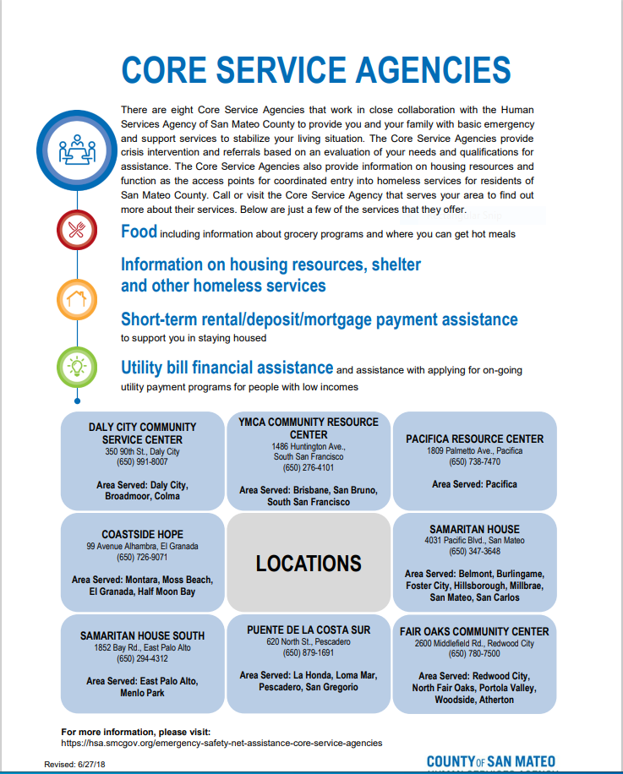
- Include detailed location, description of individual and/or contact info, the services the client is interested in, and any other details that could be useful
Alternative to Direct LM Referrals:
CORE Service Agencies

LifeMoves General Info:
LifeMoves is a nonprofit organization that is dedication to finding solutions to homelessness in Silicon Valley.
Work throughout San Mateo County to meet unsheltered clients where they are and provide services in the field.
HOT is the LifeMoves “boots on the ground” – spending every day canvasing the streets and known encampments to identify, build relationships, and assist unsheltered clients as needed
--
Single Adult Services
- Shelters
  - Navigation Center/Maple Street

- Housing Services
  - Rapid Re-Housing programs
  - Assistance locating affordable housing
  - Housing benefits and rental applications

- Field Outreach Services
  - Homeless Outreach Team (HOT)
  - Healthcare for the Homeless
  - Hospital Outreach

- Employment Programs
  - Career skills development
  - Resume workshops
  - Job search support

- Education Programs
  - Financial literacy
  - Health & wellness workshops

Family Services
Shelters & Housing
- First Step for Families
- Redwood Family House
- Haven Family House
- Family Crossroads

